SOCIAL MEDIA
IS SOCIAL MEDIA GOOD OR BAD?
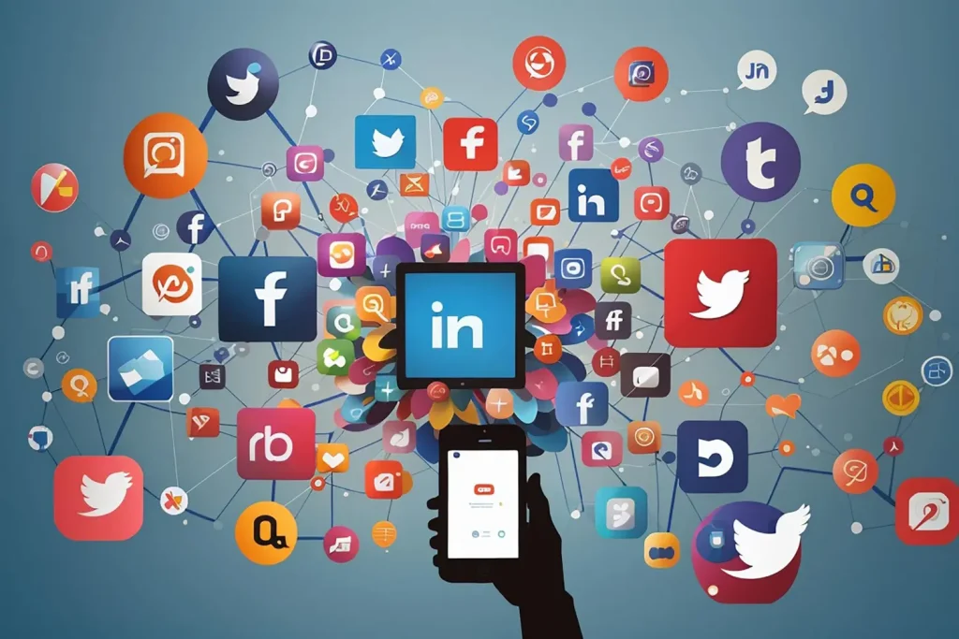
Muhammad Saad Khan
24k-0680

Table of Contents
1.Is Social Media Good or Bad? 2
2.The Positive Aspects of Social Media 3
2.1 Enhanced Communication and Connectivity 3
2.2A Platform for Advocacy and Change 3
3. Access to Information and Learning 3
4.The Negative Aspects of Social Media 4
4.1. Mental Health Concerns 4
4.2. Misinformation and Polarization 4
5.Striking a Balance 5
5.1. Set Boundaries: 5
5.2. Curate Your Feed: 6
6.Conclusion 6
7.REVIEWS 7

1.Is Social Media Good or Bad?
Social media has become an integral part of our daily lives, influencing how we communicate, consume information, and even perceive ourselves and others. With billions of users worldwide, platforms like Facebook, Twitter, Instagram, and TikTok have revolutionized the way we connect and share. However, this transformation brings with it a complex array of benefits and challenges. So, is social media good or bad? The answer isn’t straightforward; it encompasses a spectrum of impacts on individuals and society. (wikipedia, 2024)

2.The Positive Aspects of Social Media

2.1 Enhanced Communication and Connectivity
One of the most significant advantages of social media is its ability to connect people across vast distances. Friends and family members can stay in touch easily, sharing updates, photos, and experiences in real-time. For many, social media provides a sense of belonging and community, particularly for those who may feel isolated in their everyday lives. Groups and pages dedicated to various interests allow users to find like-minded individuals, fostering relationships that may not have been possible otherwise. (wikipedia, 2024)

2.2A Platform for Advocacy and Change
Social media has emerged as a powerful tool for social and political activism. Movements like #MeToo and Black Lives Matter have gained momentum through platforms like Twitter and Instagram, allowing users to mobilize support and spread awareness on critical issues. Social media provides a voice for the marginalized and can drive significant change, influencing public opinion and policy. In times of crisis, it can be a vital channel for information dissemination and community organization. (wikipedia, 2024)

3. Access to Information and Learning
The internet is a treasure trove of information, and social media serves as a gateway to diverse perspectives and knowledge. Users can access news updates, educational content, and expert opinions instantaneously. This democratization of information can promote awareness and understanding of global events, health issues, and cultural movements. Educational institutions and professionals utilize social media to share insights, making learning more accessible and engaging. (website, 2024)

4.The Negative Aspects of Social Media

4.1. Mental Health Concerns
While social media can foster connection, it can also contribute to feelings of inadequacy, anxiety, and depression. Users often curate their lives online, leading to a distorted perception of reality. The constant comparison to others’ seemingly perfect lives can result in low self-esteem and a negative body image. Studies have shown a correlation between heavy social media use and mental health issues, particularly among adolescents and young adults. Cyberbullying further exacerbates this problem, as individuals can face harassment or negative comments from anonymous users, impacting their mental well-being.

4.2. Misinformation and Polarization
The rapid spread of information on social media is a double-edged sword. While it allows for the quick dissemination of news, it also facilitates the spread of misinformation and fake news. Users may encounter misleading information that can shape their beliefs and opinions, often without proper context or fact-checking. This phenomenon contributes to societal polarization, as people gravitate towards echo chambers that reinforce their existing views, leading to division and conflict within communities.

4.3. Privacy and Security Risks
Social media platforms often collect vast amounts of personal data, raising significant privacy concerns. Users may unknowingly share sensitive information, which can be exploited by advertisers, hackers, or even malicious entities. High-profile data breaches have raised awareness about the vulnerabilities of social media, prompting calls for stricter regulations. Additionally, the permanence of online interactions can lead to long-lasting repercussions, as past posts and comments may resurface in ways that affect personal and professional reputations.

5.Striking a Balance
The question of whether social media is good or bad does not lend itself to a simple answer. Its impact is contingent upon how we use these platforms and the intentions behind our interactions. Individuals must navigate the digital landscape with mindfulness, recognizing both the benefits and drawbacks. Here are a few strategies to cultivate a healthier relationship with social media:
5.1. Set Boundaries: Limit the time spent on social media to avoid excessive scrolling and potential negative impacts on mental health. Designate specific times for checking updates rather than allowing it to disrupt daily activities.
5.2. Curate Your Feed: Follow accounts that promote positivity, education, and diverse perspectives. Unfollow or mute accounts that trigger negative feelings or contribute to a distorted self-image.
5.3. Engage Critically: Approach information on social media with skepticism. Verify sources before sharing content and engage in discussions that promote understanding rather than division.
5.4. Prioritize Real Connections: Use social media as a tool to enhance face-to-face relationships rather than replace them. Organize meetups with online friends or use platforms to coordinate activities with local communities.

6.Conclusion
In conclusion, social media is neither inherently good nor bad; it reflects human behavior and society’s evolving communication landscape. Its effects are profound, shaping our interactions, beliefs, and even our mental health. By acknowledging its potential for both positive and negative outcomes, we can harness its power while mitigating its risks. Ultimately, the responsibility lies with us as users to cultivate a balanced and intentional approach to social media, ensuring it serves as a force for good in our lives and communities.

7.REVIEWS
Heading | 1 | 2 | 3 | 4 | 5 | 6
Do you agree with this heading content?
- Place a tick or a cross.

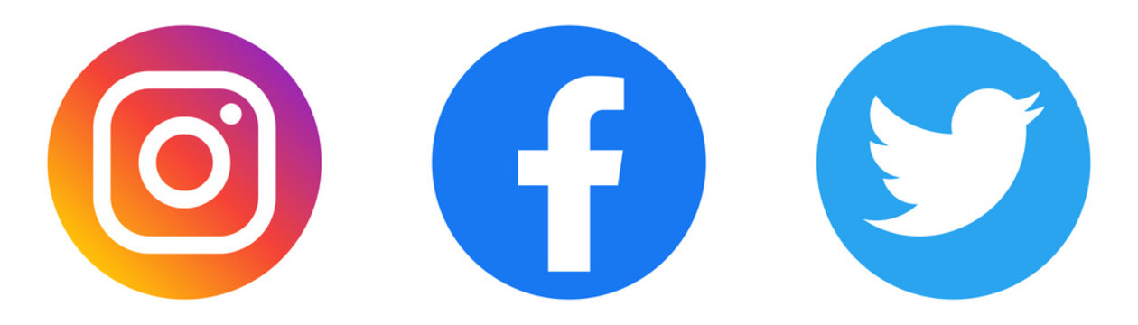
Figure 1-Social Media

Bibliography
(n.d.). Retrieved from wikipedia.
(n.d.). Retrieved from wikipedia.
(2024). Retrieved from wikipedia.
(2024, 9 30). Retrieved from website.
(2024). Retrieved from wikipedia.
(2024). Retrieved from wikipedia.

